INSTALLATION INSTRUCTION 6,

cid:image003.jpg@01D030AA.9208D3D0FOR APPLICATION OF VAPOUR PERMEABLE MEMBRANES AS A PROTECTION-DISTANCING LAYER BETWEEN THERMAL INSULATION AND ROOF SHEATHING

rys. 2 - 5.tifdo instr. 1 c-b.tifThis instruction concerns most important rules of installation vapour-permeable membrane referred to as “ICM” with DoP type 90 – type 265 functioning as a distancing material between thermal insulation and sheathing in ventilated roofs.

Pic.1

In such roofs ICM maintains necessary distance between sheathing and thermal insulation, protecting it from humidity coming together with the ventilating air. It affects especially mineral wool (glass and rock) and wood wool. Sheathings (boards, OSB or plywood etc.) are applied under coverings demanding rigid supporting ground (pic. 2) and under insulation sealing (bituminous felt, PVC foils etc.) coverings laid on battens and counter-battens (pic. 1).

The distance which creates the ventilation gap can be done in two ways.

The first one is shown in the pic. 2, 4 and 5. ICM is laid on roof truss and counter-battens creating a frame are fixed to the truss over it. Sheathing is fixed to this frame. The second method is about fixing ICM after making sheathing (and covering) before fixing the thermal insulation (pic. 3).

RECOMMENDATIONS

1. No matter of the method of creating the distance, the gap made by ICM between sheathing and thermal insulation must have inlet and outlet and must be permeable along its entire length (according to Instruction 2 orrys. 3 - 5.tif DIN 4108 – 3).

Pic.2

Rys.3

2. In the first method (pic. 2, 4, 5) ICM is laid on roof truss in the same way as in the sloping roofs (without sheathing) as a sealing layer for roofing laid on battens and counter-battens (according to Instruction no. 1).

3. In the second method ICM is fixed under existing sheathing to the rafters creating a ventilation gap between them. It is best to fix it on distance bars. The height of the bar is the same as the height of the gap and should be chosen according to its length and other roof conditions according to the regulations described in Instruction 2 or DIN 4108 – 3.

4. In the second method, in front of any obstacles closing the gap, there is a need to build an outlet (pic. 3) and inlet behind them, so that it is permeable along its entire length. The openings should be made in the sheathing and in the felt or any other sealing. If the condition of width of the obstacle shown in the pic. 5 is met, cutting the openings is not needed. In case of the first method (pic. 2), the obstacles can be omitted as shown in pic. 4 or 5.

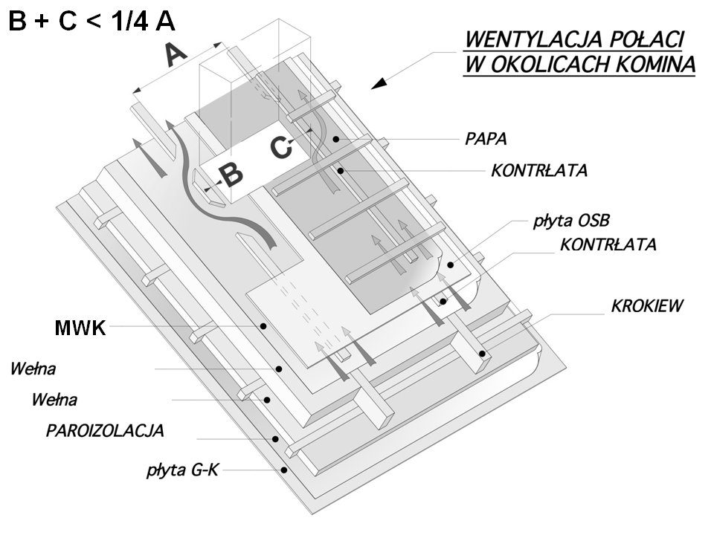

Pic.4

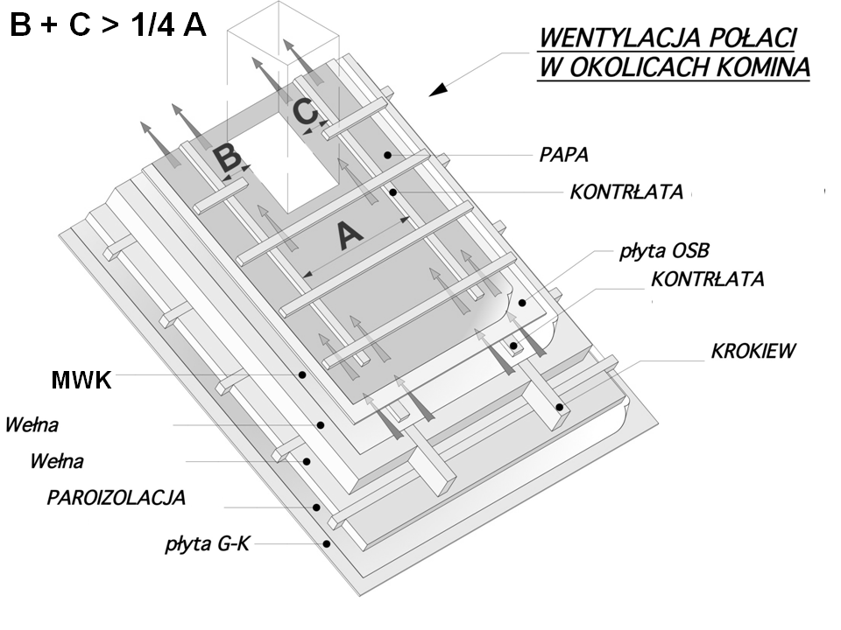

Pic.5

5. Ventilating air takes away water vapour coming through ICM. That is why, inlets and outlets of the ventilation space or gap over it must be permeable and protected from animals and the height of the gap should be properly adjusted to the roof size (pic. 1) according to the Instruction 2 or DIN 4108 – 3.

|  |  |  |
| --- | --- | --- |
| **Recommended minimal overlaps between following ICM strips** | | |
| **ICM with DoP :**  **type 90 – type 155** | 10º - 20º (17,6% - 36,4%) | **15 cm** |
| 21º - 35º (38,4% - 70% ) | **10 cm** |
| 36º - 90º ( ≥ 72,6% ) | **5 cm** |
| **ICM with DoP :**  **type 160 – type 265** | 5º - 15º (8,8% - 26,8%) | **15 cm** |
| 16º - 35º (28,7% - 70% ) | **10 cm** |
| 36º - 90º ( ≥ 72,6% ) | 1. **cm** |

6. ICM is installed thinner nonwoven inside and overprint outside the roof. The most effective way of installation of ICM is to start from the eaves with strips parallel to the rafters using overlaps whose size depends on the roof sloping (table above) and mass of the ICM. Protection-distancing layer can be also laid parallel to the eaves (perpendicularly to the rafters) as needed in work organization. Strips laid on neighboring roof surfaces should overlap in the ridge creating an overlap with size of min. 15 cm. In the roof corners the strips of membranes from neighboring surfaces should also overlap.

7. The tightness of the layer depends on the way the connections of ICM with all other elements creating roof are made. It applies to places where installations like: ventilators, vents, antennae etc. are going through the roof and connections with chimneys, walls, etc. On walls and similar elements, overlap connection must drain water on the outside of the membrane. The tighter the sealing, the better protection of the roof by this layer.

8. Around chimneys, hatches, roof windows etc. ICM should be sealed by means of double-sided tape, so that its fragments are curled up.

9. All connections with elements going through ICM are best sealed by means of self-adhesive tapes intended for this purpose (e.g. MARMA K1, N2, O1, W1, etc.) or glues intended for this purpose.

10. All remarks and reservations enumerated in instruction no. 1 are also binding by installation of ICM as a protection-distancing layer in ventilated roofs (according to this instruction no. 6).



**Instruction written according to the state of knowledge from May 2019.**

Additional information on websites:

[www.marma.com.pl](http://www.marma.com.pl) i [www.dachowa.com.pl](http://www.dachowa.com.pl) .